Declaration of Conformity (DoC)

We, Shenzhen Doke Electronic Co., LTD
801, Building3, 7th Industrial Zone, Yulv Community, Yutang Road, Guangming District, Shenzhen, China

Declare that the DoC is issued under our sole responsibility and belongs to the following product(s):

Product Type: | Tablet PC
Brand Name | Blackview
Model Number(s): | MEGA 5
Hardware Version: | J50_T7300_D4UF
Software Version: | MEGA_5_EEA_j50
Operating system: | Android

(Name of product, type or model, batch or serial number)

System components:

FPC Antenna;
gain: BT/Wi-Fi2.4G:2.13dBi; WIFI5G:2.51dBi;
GSM900:-1.12 dBi, DCS1800:0.33 dBi, WCDMA B1:0.53 dBi, WCDMA B8:-1.12 dBi,
LTE B1:0.53 dBi, LTE B3:0.33 dBi, LTE B7:0.62 dBi, LTE B8:-1.12 dBi,
LTE B20:-1.34 dBi, LTE B28:-2.61 dBi
GPS: FPC Antenna
FM: Use earphone as Antenna

Adapter:
Model: QZ-05500EC00
Brand: Blackview
Input: 100-240V~50/60Hz 1.2A
Output: 5.0V 2.0A or 5.0V 3A
(PPS)9-20V3-2.75A
Manufacturer: Guangdong Quanzhi Technology
Co.,Ltd.
Rechargeable Li-ion Battery:
Model: LiU3289113PHVUTL; Specification: DC 3.87V, 10000mAh, 38.7Wh
Manufacturer: SHENZHEN UTILITY ENERGY CO.,LTD

USB Cable: 110cm;

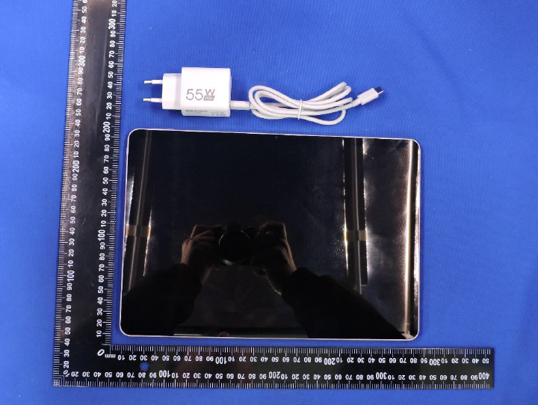

The object of the declaration described above is in conformity with the essential requirements of the relevant Union harmonization legislation: Radio Equipment Directive RED (2014/53/EU).
The following harmonized standards and technical specifications have been applied:

HEALTH & SAFETY (Art. 3(1)(a)):

EN 50566:2017;
EN 50566:2017/A1:2023
EN IEC/IEEE 62209-1528:2021
EN 62479:2010
EN IEC 62368-1:2020+A11:2020

EMC (Art. 3(1)(b)):

ETSI EN 301 489-1 V2.2.3 (2019-11)
ETSI EN 301 489-3 V2.3.2 (2023-01)
ETSI EN 301 489-17 V3.3.1 (2024-09)
ETSI EN 301 489-19 V2.2.1 (2022-09)
ETSI EN 301 489-52 V1.3.1 (2024-11) EN 55032:2015+A11:2020
EN 55035:2017+A11:2020
EN IEC 61000-3-2:2019+A2:2024 EN 61000-3-3:2013+A2:2021+AC:2022

Radio Spectrum (Article 3.2):

ETSI EN 301 511 V12.5.1 (2017-03);
TS 151 010-1 V13.14.0 (2024-06)
ETSI EN 301 908-1 V15.2.1 (2023-01)
ETSI EN 301 908-2 V13.1.1 (2020-06);
ETSI EN 301 908-13 V13.3.1 (2024-10)
ETSI EN 300 328 V2.2.2 (2019-07);
ETSI EN 301 893 V2.1.1 (2017-05)
ETSI EN 300 440 V2.2.1 (2018-07)
ETSI EN 303 413 V1.2.1 (2021-04) ;
ETSI EN 303 345-1 V1.1.1 (2019-06);
ETSI EN 303 345-3 V1.1.1 (2021-06)

The submitted samples of the above equipment has been tested and found to comply with the following European
Directives: RoHS Directive 2011/65/EU & (EU) 2015/863

RF Specification:

Function | Operation Frequency | Max RF output power:
BLE | 2402MHz–2480MHz | 4.54 dBm
BT(BR+EDR) | 2402MHz–2480MHz | 3.86 dBm
WIFI 802.11b/g/  n(HT20/40) | 802.11b/g/n(20MHz): 2412~2472MHz;  802.11n(40MHz):2422~2462MHz | 13.95dBm
Wi-Fi  5.2G(802.11a/n20/n40/ac2  0/ac40/ac80) | 802.11a/ n20/ac20:5180MHz~5240MHz  802.11 n40/ac40:5190MHz~5230MHz  802.11 ac80:5210MHz | 13.58dBm
Wi-Fi  5.8G(802.11a/n20/n40/ac2  0/ac40/ac80) | 802.11a/ n20/ac20:5745MHz~5825MHz  802.11 n40/ac40:5755MHz~5795MHz  802.11 ac80:57750MHz | 11.58 dBm
GSM/GPRS/EGPRS 900 | TX(Uplink):880M-915MHZ;  RX(Downlink):925M-960MHZ | 33.19 dBm
GSM/GPRS/EGPRS 1800 | TX(Uplink):1710M-1785MHZ;  RX(Downlink):1805M-1880MHZ | 30.76 dBm
WCDMA B1 | TX(Uplink):1920-1980MHz;  RX(Downlink):2110-2170MHz | 23.66 dBm
WCDMA B8 | TX(Uplink): 880-915MHz;  RX(Downlink):925-960MHz | 23.56 dBm
LTE FDD B1 | TX(Uplink):1920-1980MHz;  RX(Downlink):2110-2170MHz | 23.74 dBm
LTE FDD B3 | TX(Uplink) :1710-1785MHz;  RX(Downlink):1805-1880MHz | 23.88 dBm
LTE FDD B7 | TX(Uplink) :2500-2570MHz;  RX(Downlink):2620-2690MHz | 23.65 dBm
LTE FDD B8 | TX(Uplink): 880MHz to 915 MHz  RX(Downlink): 925 MHz to 960 MHz | 23.56 dBm
LTE FDD B20 | TX(Uplink): 832MHz~862MHz;  RX(Downlink):791MHz~821MHz | 23.51 dBm
LTE FDD B40 | Uplink & Downlink: 2300 MHz to 2400 MHz | 23.43dBm
FM | Rx(Downlink): 87.5MHz~108MHz | --
GPS | Rx(Downlink): 1.57542GHz | --

Tests for SAR are conducted using standard operating positions with the device transmitting at its

highest certified power level in all tested frequency bands. The maximum SAR values tested on this device when used in its normal position at the ear and when used closet othe body(at a minimum distance of 5mm/0mm) are:

Max SAR Value(W/kg) Limitis 2.0(W/kg) for10-g | Body | 1.611W/kg
Max SAR Value(W/kg) Limitis 4.0(W/kg) for10-g | Member DAS | 1.611W/kg

Technical file held by: Shenzhen Doke Electronic Co., LTD
Address: 801, Building3, 7th Industrial Zone, Yulv Community, Yutang Road, Guangming District, Shenzhen, China

Signed for and on behalf of: Shenzhen Doke Electronic Co., LTD

Name and Title: | Xie ce / Manager
Address: | 801, Building3, 7th Industrial Zone, Yulv Community, Yutang Road, Guangming District, Shenzhen, China



Signature of Authorized Person
2026-05-11

