Declaration of Conformity (DoC)

W e, Shenzhen Doke Electronic Co., LTD

801, Building3, 7th Industrial Zone, Yulv Community, Yutang Road, Guangming District, Shenzhen, China

Declare that the DoC is issued under our sole responsibility and belongs to the following product(s):

Product Type: | Tablet
Trademark： | Blackview
Model Number(s): | ZENO 2, ZENO 2 Kids
Hardware Version: | L30-T310-V1.0
Software Version: | ZENO 2: ZENO_2_EEA_L30_V1.0_A16  ZENO 2 Kids: ZENO_2_Kids_EEA_L30_V1.0_A16

(Name of product, type or model, batch or serial number)

System components:

Antenna:PIFA Antenna

gain: BT/Wi-Fi2.4G: 1.8 dBi ; WIFI 5.2G: 1.6 dBi;
WIFI 5.8G：1.6 dBi dBi

GSM:
GSM900:-1.7dBi ;DCS1800:0.8dBi

WCDMA:
Band Ⅰ:1.0dBi ;Band Ⅷ: -1.7dBi

LTE:
Band 1: 0.9dBi; Band 3: 0.8dBi; Band 7:0.7dBi; Band 8: -1.7dBi; Band 20: -1.8dBi; Band 28: -2.0dBi;

GPS: PIFA Antenna
FM: Use earphone as Antenna

Adapter:
Model: QZ-01004EA00
Input: 100-240V~50/60Hz 0.3A Output: 5.0V 2.0A, 10.0W

Rechargeable L-ion Battery
Model: U32100100PHVUTL; Specification: DC 3.85V, 5000mAh, 19.25Wh
Manufacturer: SHENZHEN UTILITY ENERGY CO., LTD.

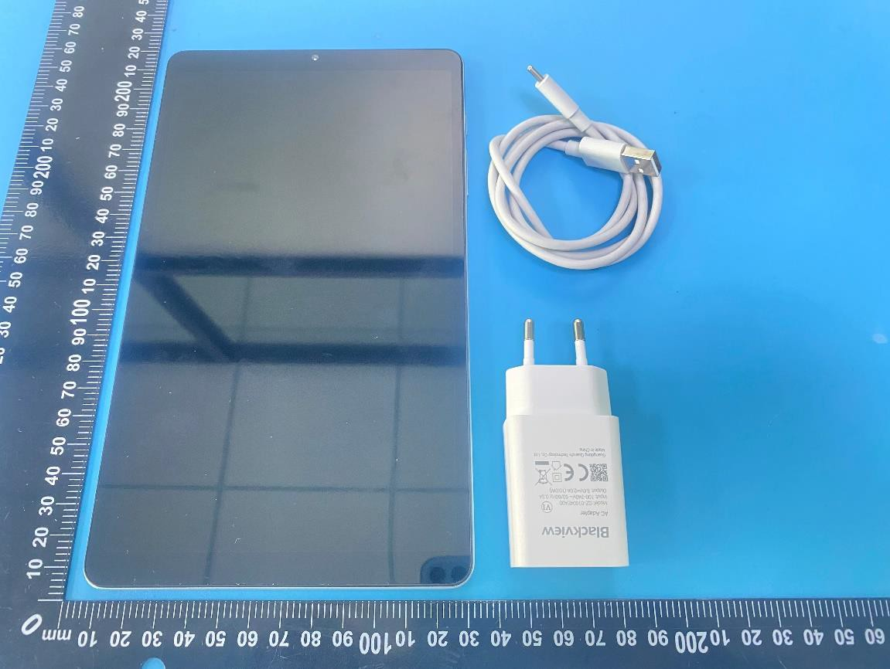
The object of the declaration described above is in conformity w ith the essential requirements of the relevant Union harmonization legislation: Radio Equipment Directive RED (2014/53/EU).
The following harmonized standards and technical specifications have been applied:

HEALTH & SAFETY (Art. 3(1)(a)):
EN 50566:2017;
EN 50566:2017+A1:2023;
EN IEC/IEEE 62209-1528:2021;
EN 62479:2010;
EN IEC 62368-1:2020+A11:2020

EMC (Art. 3(1)(b)):
ETSI EN 301 489-1 V2.2.3 (2019-11)
ETSI EN 301 489-3 V2.3.2 (2023-01)
ETSI EN 301 489-17 V3.3.1 (2024-09)
ETSI EN 301 489-19 V2.2.1 (2022-09)
ETSI EN 301 489-52 V1.3.1 (2024-11) EN 55032:2015+A1:2020;
EN 55035:2017+A11:2020
EN IEC 61000-3-2:2019+A2:2024; EN 61000-3-3:2013+A2:2021

Radio Spectrum (Article 3.2):

ETSI EN 300 328 V2.2.2 (2019-07)
ETSI EN 301 893 V2.1.1 (2017-05)
ETSI EN 300 440 V2.2.1 (2018-07)
ETSI EN 301 511 V12.5.1 (2017-03)
ETSI EN 301 908-1 V15.2.1 (2023-01)
ETSI EN 301 908-2 V13.1.1 (2020-06)
ETSI EN 301 908-13 V13.3.1 (2024-10)
ETSI EN 303 413 V1.2.1 (2021-04)
ETSI EN 303 345-1 V1.1.1 (2019-06)
ETSI EN 303 345-3 V1.1.1 (2021-06)

The submitted samples of the above equipment has been tested and found to comply with the

following European Directives: RoHS Directive 2011/65/EU & (EU) 2015/863

NOTIFIEDBODY:

Name:LGAI TECHNOLOGICAL CENTER, S.A. (APPLUS)

Address: Ronda de la Font del Carme, s/n 08193 Bellaterra – Barcelona (Spain) IdentificationNumber: 0370

EU-type examination certificate number: 0370-RED-12181

RF Specification:

Function | Operation Frequency | Max RF output power:
BLE | 2402MHz–2480MHz | -1.03dBm
BT(BR+EDR) | 2402MHz–2480MHz | 4.51dBm
WIFI 802.11b/g/ n(HT20/40) | 802.11b/g/n(20MHz): 2412~2472MHz;  802.11n(40MHz):2422~2462MHz | 16.77dBm
WIFI 5.2G | 5180~5240MHz | 13.55dBm
WIFI 5.8G | 5745~5825 MHz | 12.84dBm
GSM/GPRS/EGPRS 900 | TX(Uplink):880M-915MHZ; RX(Downlink):925M-960MHZ | 31.58dBm
GSM/GPRS/EGPRS 1800 | TX(Uplink):1710M-1785MHZ; RX(Downlink):1805M-1880MHZ | 29.57dBm
WCDMA B1 | TX(Uplink):1920-1980MHz;  RX(Downlink):2110-2170MHz | 21.49dBm
WCDMA B8 | TX(Uplink): 880-915MHz;  RX(Downlink):925-960MHz | 21.58dBm
LTE FDD B1 | TX(Uplink):1920-1980MHz;  RX(Downlink):2110-2170MHz | 23.62dBm
LTE FDD B3 | TX(Uplink) :1710-1785MHz;  RX(Downlink):1805-1880MHz | 23.62dBm
LTE FDD B7 | TX(Uplink) :2500-2570MHz;  RX(Downlink):2620-2690MHz | 23.86dBm
LTE FDD B8 | TX(Uplink): 880MHz to 915 MHz RX(Downlink): 925 MHz to 960 MHz | 23.42dBm
LTE FDD B20 | TX(Uplink): 832MHz~862MHz; RX(Downlink):791MHz~821MHz | 22.95dBm
LTE FDD B28 | TX(Uplink): 703MHz~736MHz; RX(Downlink):758MHz~791MHz | 22.04dBm
FM | Rx(Downlink): 87.5MHz~108MHz | --
GPS | Rx(Downlink): 1575.42MHz | --

Tests for SAR are conducted using standard operating positions with the device transmitting at its

highest certified power level in all tested frequency bands. The maximum SAR
values tested on this device when used in its normal position at the body and limbs (at a minimum distance of 5mm/0mm) are:

Max SAR Value(W /kg) Limitis 2.0(W /kg) for10-g | Body | 1.743W/kg
Max SAR Value(W /kg) Limitis 4.0(W /kg) for10-g | Member DAS | 3.848W/kg

Technical file held by: Shenzhen Doke Electronic Co., LTD

Address: 801, Building3, 7th Industrial Zone, Yulv Community, Yutang Road, Guangming District, Shenzhen, China

Signed for and on behalf of: Shenzhen Doke Electronic Co., LTD
Name and Title: | Huang tianyu
Address: | 801, Building3, 7th Industrial Zone, Yulv Community, Yutang Road, Guangming District, Shenzhen, China



Signature of Authorized Person
2026-7-14

