Declaration of Conformity (DoC)

We, Shenzhen Doke Electronic Co., LTD
801, Building3, 7th Industrial Zone, Yulv Community, Yutang Road, Guangming District, Shenzhen, China

Declare that the DoC is issued under our sole responsibility and belongs to the following product(s):

Product Type: | Smart Phone
Trademark： | Blackview
Model Number(s): | ROCK 5, BV9300Pro Plus
Hardware Version: | E5J7_MAIN_PCB_V1.1
Software Version: | N/A
Operating system: | Android

(Name of product, type or model, batch or serial number)

System components:

PIFA Antenna; gain: BT/Wi-Fi2.4G: 1.45dBi; WIFI5G:1.09dBi; GSM900:-4.21dBi/DCS1800:0.17dBi
WCDMA:Band Ⅰ:0.84dBi ;Band Ⅷ:-4.58dBi;

LTE: Band 1: 0.89dBi; Band 3: 0.18dBi; Band 7:1.37dBi; Band 8: -4.24dBi; Band 20: -5.85dBi; Band 28: -6.54dBi; GPS: PIFA Antenna; NFC: Coil Antenna
FM: Use earphone as Antenna

Adapter:
Model: QZ-03301EC00
Brand: Blackview
Input: 100-240~50/60Hz 1.2A
Output: 5.0V 3.0A 15.0W or 9.0V 3.0A 27.0W or 12.0V 2.5A 30.0W or 15.0V 2.0A 30.0W or 20.0V 1.5A 30.0W Max
PPS: 5.0V-11.0V 3.0A 33.0W Max
Manufacturer: Guangdong Quanzhi Technology Co.,Ltd. Rechargeable Li-ion Battery:
Model: U476591PNJ; Specification: DC 3.85V, 5000mAh,19.25Wh
Manufacturer: Guangdong Quanzhi Technology Co.,Ltd

USB Cable: 110cm;

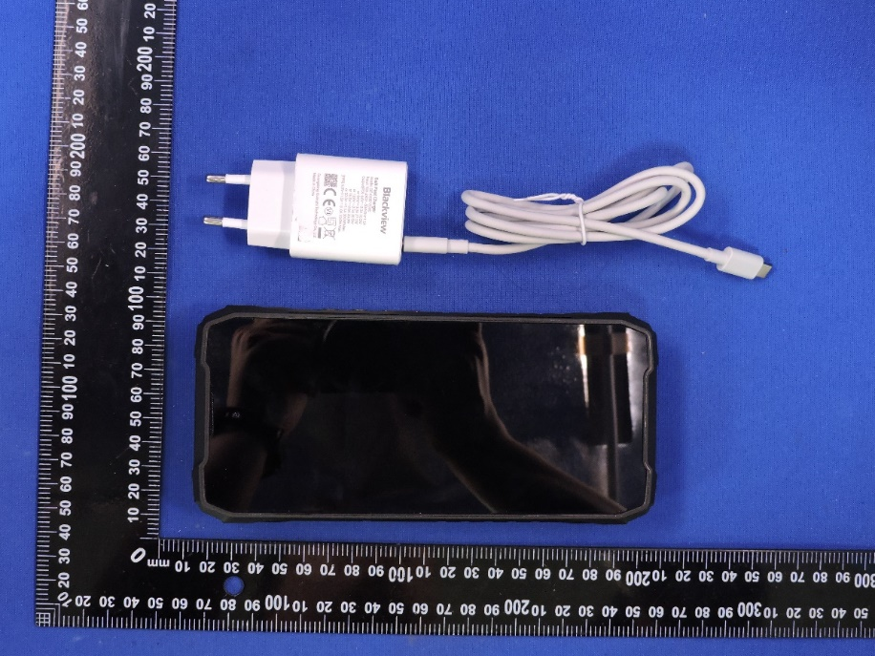

The object of the declaration described above is in conformity with the essential requirements of the relevant Union harmonization legislation: Radio Equipment Directive RED (2014/53/EU).
The following harmonized standards and technical specifications have been applied:

HEALTH & SAFETY (Art. 3(1)(a)):

EN IEC 62368-1:2020+A11:2020

EN 50360: 2017+A1:2023;

EN 50566: 2017+A1:2023

EN IEC/IEEE 62209-1528: 2021

EN 50663: 2017; EN 62479: 2010

EMC (Art. 3(1)(b)):

EN 301 489-1 V2.2.3 (2019-11)

EN 301 489-3 V2.3.2 (2023-01)

EN 301 489-17 V3.3.1(2024-09)

EN 301 489-19 V2.2.1 (2022-09)

EN 301 489-52 V1.3.1 (2024-11)

EN 55032:2015+A11:2020

EN IEC 61000-3-2:2019+A2:2024

EN 61000-3-3:2013+A2:2021+AC:2022

EN 55035:2017+A11:2020

Radio Spectrum (Article 3.2):

EN 301 511 V12.5.1 (2017-03)

TS 151 010-1 V13.14.0 (2024-06)

EN 301 908-1 V15.2.1 (2023-01)

EN 301 908-2 V13.1.1 (2020-06)

EN 301 908-13 V13.3.1 (2024-10)

EN 300 328 V2.2.2 (2019-07)

EN 301 893 V2.1.1 (2017-05)

EN 300 440 V2.2.1 (2018-07)

EN 303 345-1 V1.1.1 (2019-06)

EN 303 345-3 V1.1.1 (2021-06)

EN 303 413 V1.2.1 (2021-04)

EN300 330 V2.1.1 (2017-02)
The submitted samples of the above equipment has been tested and found to comply with the following European
Directives: RoHS Directive 2011/65/EU & (EU) 2015/863

NOTIFIEDBODY:

Name: LGAl Technological Center S.A. (APPLUS)

Address: Campus UAB. Ronda de la Font del Carme s/n08193 Bellaterra, Barcelona (Spain)

IdentificationNumber: 0370

EU-type examination certificate number: No. 0370-RED-11439

RF Specification:

Function | Operation Frequency | Max RF output power:
BLE 1M | 2402MHz–2480MHz | 3.95 dBm
BT(BR+EDR) | 2402MHz–2480MHz | 3.65 dBm
WIFI 802.11b/g/  n(HT20/40) | 802.11b/g/n(20MHz): 2412~2472MHz;  802.11n(40MHz):2422~2462MHz | 13.95dBm
Wi-Fi  5.2G(802.11a/n20/n40/ac2  0/ac40/ac80) | 802.11a/ n20/ac20:5180MHz~5240MHz  802.11 n40/ac40:5190MHz~5230MHz  802.11 ac80:5210MHz | 13.58 dBm
Wi-Fi  5.8G(802.11a/n20/n40/ac2  0/ac40/ac80) | 802.11a/ n20/ac20:5745MHz~5825MHz  802.11 n40/ac40:5755MHz~5795MHz  802.11 ac80:57750MHz | 11.60 dBm
GSM/GPRS/EGPRS 900 | TX(Uplink):880M-915MHZ;  RX(Downlink):925M-960MHZ | 32.84 dBm
GSM/GPRS/EGPRS 1800 | TX(Uplink):1710M-1785MHZ;  RX(Downlink):1805M-1880MHZ | 29.94 dBm
WCDMA B1 | TX(Uplink):1920-1980MHz;  RX(Downlink):2110-2170MHz | 22.86 dBm
WCDMA B8 | TX(Uplink): 880-915MHz;  RX(Downlink):925-960MHz | 23.84 dBm
LTE FDD B1 | TX(Uplink):1920-1980MHz;  RX(Downlink):2110-2170MHz | 23.37dBm
LTE FDD B3 | TX(Uplink) :1710-1785MHz;  RX(Downlink):1805-1880MHz | 22.65 dBm
LTE FDD B7 | TX(Uplink) :2500-2570MHz;  RX(Downlink):2620-2690MHz | 22.56 dBm
LTE FDD B8 | TX(Uplink): 880MHz to 915 MHz  RX(Downlink): 925 MHz to 960 MHz | 22.94 dBm
LTE FDD B20 | TX(Uplink): 832MHz~862MHz;  RX(Downlink):791MHz~821MHz | 23.11 dBm
LTE FDD B28 | TX(Uplink): 703-748 MHz (TX),  RX(Downlink): 758-803 MHz | 22.98dBm
FM | Rx(Downlink): 87.5MHz~108MHz | --
GPS | Rx(Downlink): 1.57542GHz | --
NFC | 13.56 MHz | -40.46dBm

Tests for SAR are conducted using standard operating positions with the device transmitting at its

highest certified power level in all tested frequency bands. The maximum SAR values tested on this device when used in its normal position at the ear and when used closet othe body(at a minimum distance of 0mm) are:

Max SAR Value(W/kg) Limitis 2.0(W/kg) for10-g | Head | 0.785 W/kg
Max SAR Value(W/kg) Limitis 2.0(W/kg) for10-g | Body | 0.534W/kg
Max SAR Value(W/kg) Limitis 4.0(W/kg) for10-g | Member DAS | 0.534W/kg

Technical file held by: Shenzhen Doke Electronic Co., LTD
Address: 801, Building3, 7th Industrial Zone, Yulv Community, Yutang Road, Guangming District, Shenzhen, China

Signed for and on behalf of: Shenzhen Doke Electronic Co., LTD

Name and Title: | Hong zongqing/ Manager
Address: | 801, Building3, 7th Industrial Zone, Yulv Community, Yutang Road, Guangming District, Shenzhen, China



Signature of Authorized Person
2026.5.6

