Declaration of Conformity (DoC)

We, Shenzhen Doke Electronic Co., LTD
801, Building3, 7th Industrial Zone, Yulv Community, Yutang Road, Guangming District, Shenzhen, China

Declare that the DoC is issued under our sole responsibility and belongs to the following product(s):

Product Type: | Smart Phone
Trademark： | Blackview
Model Number(s): | ROCK 2 Pro
Operating system:
Hardware Version:S823H_V2.1

Software Version :ROCK2Pro_EEA_S7608H_V1.0_A16

(Name of product, type or model, batch or serial number)

System components:

PIFA Antenna: BT/Wi-Fi2.4G:1.5dBi; WIFI5G:1.9dBi

GSM 900:-1.7dBi, GSM 1800:1.4 dBi
WCDMA B1 1.5 dBi, WCDMA B8 -1.7 dBi
LTE B1 1.5 dBi, LTE B3 1.4 dBi, LTE B7 1.3 dBi, LTE B8 -1.7 dBi, LTE B20 -1.3 dBi, LTE B28 -1.8 dBi
NR n1: 1.5 dBi, NR n3: 1.4 dBi, NR n8: -1.7 dBi, NR n20: -1.3 dBi, NR n28: -1.8 dBi, NR n40: 1.4 dBi,
NR n77: 2.1 dBi, NR n78: 2 dBi

GPS: PIFA Antenna
Adapter:
Model: HJ-C6-33-EU
Input: 100-240V~50/60Hz 0.8A
Output: 5.0V3.0A 15.0W OR 9.0V3.0A 27.0W OR 12.0V2.5A 30.0W OR15.0V2.0A 30.0W
OR 20.0V1.5A 30.0W
PPS:3.3V-11V3.0A 33.0W MAX
Manufacturer: SHEN ZHEN HUAJIN ELECTRONICS CO.. LTD
Rechargeable Li-ion Battery:
Model: LiU536587PHTT; Specification: DC 3.85V, 15000mAh
Manufacturer: SHENZHEN HUATIANTONG TECHNOLOGY CO.LTD
USB Cable: 100cm;

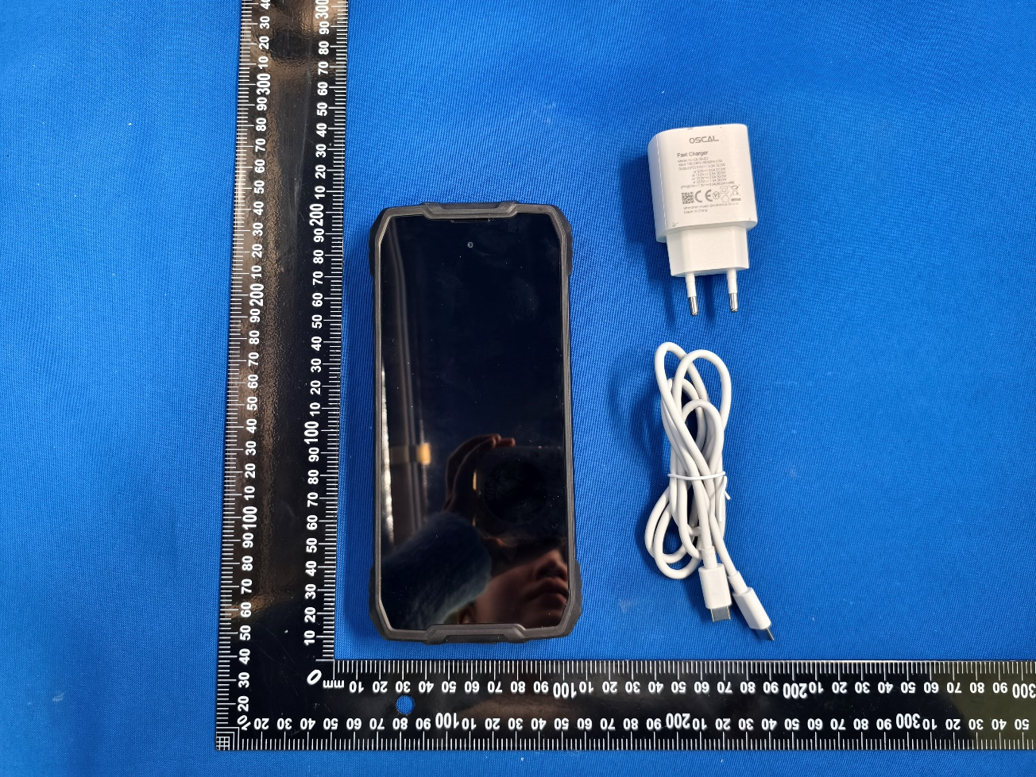

The object of the declaration described above is in conformity with the essential requirements of the relevant Union harmonization legislation: Radio Equipment Directive RED (2014/53/EU).
The following harmonized standards and technical specifications have been applied:

HEALTH & SAFETY (Art. 3(1)(a)):

EN 50360:2017+A1:2023 EN 50566:2017+A1:2023 EN IEC/IEEE 62209-1528:2021 EN 50663:2017 EN 62479:2010
EN IEC 62368-1:2020+A11:2020
EMC (Art. 3(1)(b)):

ETSI EN 301 489-1 V2.2.3 (2019-11)

ETSI EN 301 489-3 V2.3.2 (2023-01)

ETSI EN 301 489-17 V3.3.1 (2024-09)

ETSI EN 301 489-19 V2.2.1 (2022-09)

ETSI EN 301 489-52 V1.3.1 (2024-11)

EN 55032:2015+A11:2020; EN 55035:2017+A11:2020

EN IEC 61000-3-2:2019+A2:2024; EN 61000-3-3:2013+A2:2021+AC:2022

Radio Spectrum (Article 3.2):

ETSI EN 301 511 V12.5.1 (2017-03);

ETSI EN 301 908-1 V15.2.1 (2023-01)

ETSI EN 301 908-25 V15.1.1 (2024-10)

ETSI EN 301 908-2 V13.1.1 (2020-06)

ETSI EN 301 908-13 V13.3.1 (2024-10)

EN 300 328 V2.2.2 (2019-07);

EN 301 893 V2.1.1 (2017-05);

EN 300 440 V2.2.1 (2018-07);

EN 303 413 V1.2.1 (2021-04);

EN300 330 V2.1.1 (2017-02)

The submitted samples of the above equipment has been tested and found to comply with the following European Directives:
RoHS Directive 2011/65/EU & (EU) 2015/863

Notified Body Involved:

Notified Body Name: DERYCOM CERTIFICATION SERVICES, INC.
Notified Body Number: 3052
Notified Body Assessment Performed: Module B/C on Article 3.1a, 3.1b, 3.2 EU-type examination certificate number: JEC-59

RF Specification:

Function | Operation Frequency | Max RF output power:
BLE | 2402MHz–2480MHz | 3.10dBm
BT(BR+EDR) | 2402MHz–2480MHz | 3.83dBm
WIFI 2.4G  802.11b/n(20MHz):  802.11n(40MHz): | 802.11b/n(20MHz):2412-2472MHz  802.11n(40MHz):2422~2462MHz | 13.89dBm
Wi-Fi 5.2G  802.11a/n/ac (20MHz):  802.11n/ac(40MHz):  802.11ac(80MHz): | 802.11a/n/ac (20MHz):5180~5240MHZ  802.11n/ac(40MHz):5190~5230MHZ  802.11ac(80MHz):5210MHz | 13.60dBm
Wi-Fi 5.8G  802.11a/n/ac (20MHz):  802.11n/ac(40MHz):  802.11ac (80MHz): | 802.11a/n/ac(20MHz):5745~5825MHz  802.11n /ac(40MHz):5755~5795MHz  802.11ac (80MHz):5775MHz | 11.55dBm
GSM/GPRS/EGPRS 900 | TX(Uplink):880M‐915MHZ;  RX(Downlink):925M‐960MHZ | 34.27dBm
GSM/GPRS/EGPRS 1800 | TX(Uplink):1710M‐1785MHZ;  RX(Downlink):1805M‐1880MHZ | 33.04dBm
WCDMA B1 | TX(Uplink):1920-1980MHz;  RX(Downlink):2110-2170MHz | 24.98 dBm
WCDMA B8 | TX(Uplink): 880-915MHz;  RX(Downlink):925-960MHz | 25.40dBm
LTE FDD B1 | TX(Uplink):1920-1980MHz;  RX(Downlink):2110-2170MHz | 24.33 dBm
LTE FDD B3 | TX(Uplink) :1710-1785MHz;  RX(Downlink):1805-1880MHz | 25.56dBm
LTE FDD B7 | TX(Uplink) :2500-2570MHz;  RX(Downlink):2620-2690MHz | 24.04dBm
LTE FDD B8 | TX(Uplink): 880MHz to 915 MHz  RX(Downlink): 925 MHz to 960 MHz | 24.98dBm
LTE FDD B20 | TX(Uplink): 832MHz~862MHz;  RX(Downlink):791MHz~821MHz | 25.01 dBm
LTE FDD B28 | TX(Uplink): 703 MHz to 748MHz  RX(Downlink): 758 MHz to 803 MHz | 24.61 dBm
SA N1 | 1920-1980 MHz (TX), 2110-2170 MHz (RX) | 22.55dBm
SA N 3 | 1710-1785 MHz (TX), 1805-1880 MHz (RX) | 21.99 dBm
SA N 8 | 880-915 MHz (TX), 925-960 MHz (RX) | 23.43dBm
SA N 20 | 832-862 MHz (TX), 791-821 MHz (RX) | 23.56dBm
SA N 28 | 703-748 MHz (TX), 758-803 MHz (RX) | 23.33dBm
SA N 40 | 2300-2400 MHz (TX), 2300-2400 MHz (RX) | 23.36dBm
SA N 77 | 3700-3800 MHz (TX), 3700-3800 MHz (RX) | 23.49dBm
SA N 78 | 3300-3800MHz(TX), 3300-3800MHz(RX) | 23.55dBm
GPS | Rx(Downlink): 1.57542GHz | --

Tests for SAR are conducted using standard operating positions with the device transmitting at its

highest certified power level in all tested frequency bands. The maximum SAR values tested on this device when used in its normal position at the ear and when used closet othe body(at a minimum distance of 5mm/0mm) are:

Max SAR Value(W/kg)  Limitis 2.0(W/kg) for10-g | 10-gHead | 0.355
Max SAR Value(W/kg)  Limitis 2.0(W/kg) for10-g | 10-gBody | 0.685
Limitis 4.0(W/kg) for10-g | 10-gMemberDAS | 0.685

Technical file held by: Shenzhen Doke Electronic Co., LTD

801, Building3, 7th Industrial Zone, Yulv Community, Yutang Road, Guangming District, Shenzhen, China

Signed for and on behalf of: Shenzhen Doke Electronic Co., LTD

Name and Title: | Zhu tengfei/Manager
Address: | 801, Building3, 7th Industrial Zone, Yulv Community, Yutang Road, Guangming District, Shenzhen, China



Signature of Authorized Person
2025-1-6

