Declaration of Conformity (DoC)

We, Shenzhen DOKE Electronic Co., Ltd
801, Building3, 7th Industrial Zone, Yulv Community, Yutang Road, Guangming District, Shenzhen, China.
Declare that the DoC is issued under our sole responsibility and belongs to the following product(s): Product Type: Tablet PC
Trademark： Blackview
Model Number(s): MEGA 3

(Name of product, type or model, batch or serial number) System components:
Antenna Type: Internal Antenna Antenna gain:
GSM:
GSM900: -2.76dBi DCS1800: 0.65dBi UTRA FDD:
Band 1: 0.87dBi
Band 8: -2.71dBi E-UTRA:
Band 1: 0.77dBi
Band 3: 0.57dBi
Band 7: 1.04dBi
Band 8: -2.63dBi
Band 20: -2.91dBi
Band 28: -3.81dBi
Band 40: 1.16dBi 2.4G Wi-Fi: 0.67dBi
5G Wi-Fi: 1.17dBi
Bluetooth/ BLE: 0.61dBi GPS: 0.7dBi

Adapter:
Model No.: HJ-45WPD-EU
Input: AC100-240V, 50/60Hz 1.5A
Output(PD): DC 5.0V, 3.0A 15.0W or 9.0V, 3.0A 27.0W or 12.0V, 2.5A 30.0W or 15.0V, 2.0A 30.0W or 20.0V, 2.25A 45.0W MAX
(PPS) 5.0V-11.0V, 3.0A 33.0W MAX (PPS) 5.0V-20.0V, 2.25A 45.0W MAX
Manufacturer: Shenzhen Huajin Electronics Co., Ltd

Rechargeable Li-ion Battery:
Model: LiU318991PHVUTL; Specification: DC3.87V/8800mAh Manufacturer: SHENZHEN UTILITY ENERGY CO.,LTD

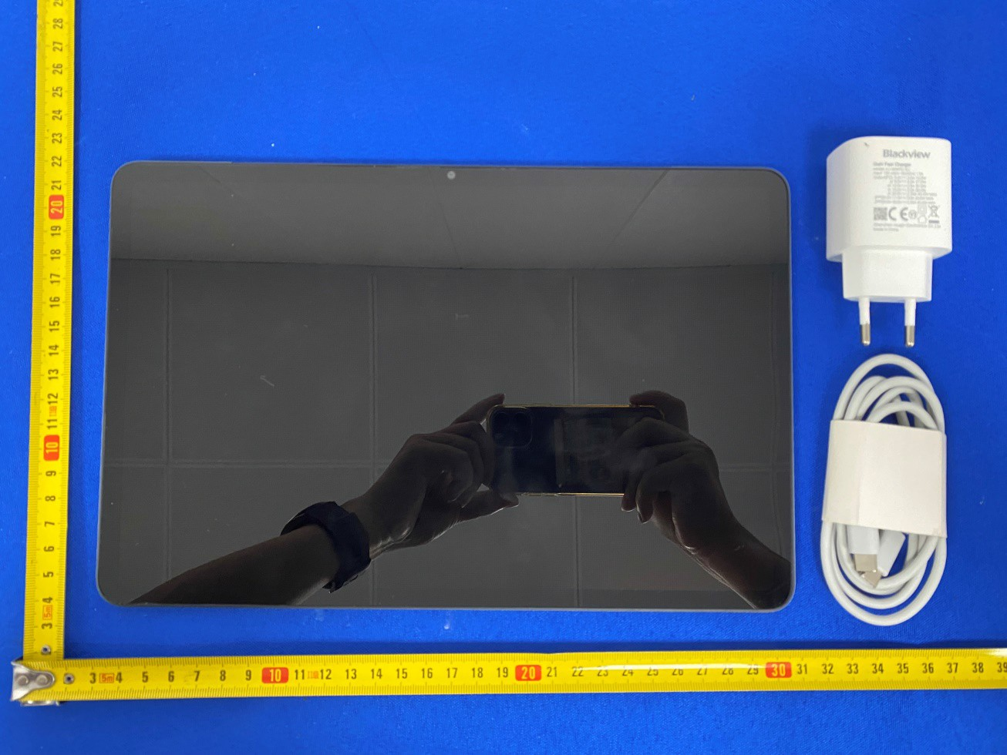

The object of the declaration described above is in conformity with the essential requirements of the relevant Union harmonization legislation: Radio Equipment Directive RED (2014/53/EU).
The following harmonized standards and technical specifications have been applied:

HEALTH & SAFETY (Art. 3(1)(a)):

EN IEC/IEEE 62209-1528:2021 EN 50566:2017+A1:2023
EN 50663:2017
EN 62479:2010
IEC 62368-1:2018
EN IEC 62368-1:2020+A11:2020

EMC (Art. 3(1)(b)):

ETSI EN 301 489-1 V2.2.3 (2019-11)

ETSI EN 301 489-3 V2.3.2 (2023-01)

ETSI EN 301 489-17 V3.3.1 (2024-09)

ETSI EN 301 489-19 V2.2.1 (2022-09)

ETSI EN 301 489-52 V1.3.1 (2024-11) EN 55032:2015+A1:2020
EN 55035:2017+A11:2020

EN IEC 61000-3-2:2019+A1:2021 EN 61000-3-3:2013+A2:2021

Radio Spectrum (Article 3.2):

EN 301 511 V12.5.1 (2017-03);

EN 301 908-1 V15.2.1 (2023-01);

EN 301 908-2 V13.1.1 (2020-06);

EN 301 908-13 V13.3.1 (2024-10);

EN 300 328 V2.2.2 (2019-07);
EN 300 440 V2.2.1(2018-07)

EN 301 893 V2.1.1 (2017-05);

EN 303 413 V1.2.1 (2021-04);

EN 303 345-1 V1.1.1 (2019-06);

EN 303 345-3 V1.1.1 (2021-06);

Notified Body Involved:

NOTIFIED BODY:
Name: DERYCOM CERTIFICATION SERVICES, INC.
Address: 1100 Falcon Avenue Glencoe, Mn 55336 Notified Body ID number: 3052
EU-type examination certificate number: JEC-01

RF Specification:

Max power:
GSM 900: 35.13 dBm
GSM 1800: 31.17dBm
WCDMA 2100: 23.22dBm
WCDMA 900:23.42 dBm LTE FDD Band 1:24.26dBm LTE FDD Band 3:23.25dBm LTE FDD Band 7:24.07dBm LTE FDD Band 8:23.97dBm LTE FDD Band 20: 23.96dBm LTE FDD Band 28:24.17dBm LTE FDD Band 40:24.91dBm 2.4GWiFi: 17.32dBm
5.2Gwifi:15.80dBm 5.8Gwifi:13.67dBm BT: 5.40dBm

Tx frequency: GSM:
GSM 900: 880MHz~915MHz
DCS 1800: 1710MHz~1785MHz UTRA FDD:
Band 1: 1920MHz~1980MHz
Band 8: 880MHz~915MHz E-UTRA:
Band 1: 1920MHz~1980MHz
Band 3: 1710MHz~1785MHz
Band 7: 2500MHz~2570MHz
Band 8: 880MHz~915MHz
Band 20: 832MHz~862MHz
Band 28: 703MHz~748MHz
Band 40: 2300MHz~2400MHz
Wi-Fi: 2412MHz~2472MHz
5150MHz~5250MHz
5725MHz~5850MHz
Bluetooth/ BLE: 2402MHz~2480MHz Rx frequency: GSM:
GSM 900: 925MHz~960MHz
DCS 1800: 1805MHz~1880MHz UTRA FDD:
Band 1: 2110MHz~2170MHz
Band 8: 925MHz~960MHz E-UTRA:
Band 1: 2110MHz~2170MHz
Band 3: 1805MHz~1880MHz
Band 7: 2620MHz~2690MHz
Band 8: 925MHz~960MHz
Band 20: 791MHz~821MHz
Band 28: 758MHz~803MHz
Band 40: 2300MHz~2400MHz
Wi-Fi: 2412MHz~2472MHz
5150MHz~5250MHz
5725MHz~5850MHz
Bluetooth/ BLE: 2402MHz~2480MHz GPS: 1575.42MHz

Tests for SAR are conducted using standard operating positions with the device transmitting at its highest certified power level in all tested frequency bands. The maximum SAR values tested on this device when used in its normal position at the ear and when used close to the body (at a minimum distance of 5mm/0mm) are:
Max SAR Value(W/kg) Limit is 2.0(W/kg) for 10-g | 10-g Body | 1.562W/kg
Limit is 4.0(W/kg) for 10-g | 10-g Member DAS | 1.562W/kg

Technical file held by: Shenzhen DOKE Electronic Co., Ltd
801, Building3, 7th Industrial Zone, Yulv Community, Yutang Road, Guangming District, Shenzhen, China.

Signed for and on behalf of: Shenzhen DOKE Electronic Co., Ltd

Name and Title: | Chenzexiong /Manager
Address: | 801, Building3, 7th Industrial Zone, Yulv Community, Yutang Road, Guangming District, Shenzhen, China.



Signature of Authorized Person
2025-5-21

